
KISHKINDA UNIVERSITY
Ballari.

Project Proposal

“PORTFOLIO”

Submitted as part of the Assessment Requirement for the
Course

Advance Web

BACHELOR OF COMPUTER APPLICATION
In
Department of Computer Applications

Submitted by
NAME : Sayeeda Daaniya
USN : KUB24BCA096

Submitted to
Mr. Srinivas Reddy

APPROVAL

Agree to Advice:
(Project Advisor)

Date Submitted:

Approved by:

Date Approved:

ABSTRACT

I am a motivated and enthusiastic BCA student currently pursuing my 4th semester at Kishkinda University, with a strong passion for technology, programming, and creative web development. I have developed knowledge in programming languages such as C, Python, Java, HTML, CSS, and JavaScript, along with database concepts like MySQL and SQL. I enjoy designing modern, responsive, and user-friendly websites that combine creativity with functionality.
I am deeply interested in software development, artificial intelligence, web technologies, and innovative digital solutions. Through academic learning and personal projects, I have worked on applications such as AI-based attendance systems, pharmacy management systems, IoT-based solutions, and automated development tools. These experiences have helped me strengthen my problem-solving abilities, logical thinking, teamwork, and communication skills.
I am also passionate about continuous learning and professional growth. I have completed certifications in Python, C Programming, Database Management Systems, Operating Systems, Unix, AI Fluency, and modern AI concepts such as Model Context Protocol (MCP). These certifications have expanded my understanding of both foundational and emerging technologies.
My career goal is to become a skilled software and web developer capable of building impactful and innovative applications that improve user experience and solve real-world problems. I am always eager to explore new technologies, take on creative challenges, and enhance my technical expertise while contributing positively to the field of technology.

ACKNOWLEDGMENT

I would like to express my heartfelt gratitude to everyone who contributed directly and indirectly to the successful completion of this portfolio project. This work would not have been possible without the guidance, encouragement, and support of many individuals.

First and foremost, I sincerely thank the respected faculty members and teachers of Kishkinda University for providing me with valuable knowledge, guidance, and continuous encouragement throughout my academic journey. Their teaching and motivation helped me strengthen my understanding of programming, web development, and emerging technologies.

I would also like to thank my friends and classmates for their cooperation, support, and helpful suggestions during the development of this project. Their discussions, feedback, and motivation inspired me to improve my work and learn new concepts with confidence.

A special note of gratitude goes to my parents and family members for their unconditional love, patience, encouragement, and constant support. Their belief in my abilities has always motivated me to work hard and achieve my goals.

I am equally thankful to various online learning platforms, educational websites, open-source communities, and technology resources that provided valuable tutorials, documentation, and practical knowledge in programming languages, web technologies, artificial intelligence, database management systems, and software development.

Working on this portfolio project has been a great learning experience that helped me improve my creativity, technical skills, problem-solving abilities, and confidence. I am grateful to everyone who encouraged and supported me throughout this journey.

INTRODUCTION:

A portfolio is a professional collection of personal, academic, and technical achievements that represents an individual’s skills, knowledge, creativity, and experience. In the modern digital era, portfolios play an important role in creating a strong professional identity and showcasing abilities effectively.

This portfolio website has been developed to present my profile, educational background, technical skills, certifications, and project experiences in a clear and attractive manner. The portfolio reflects my passion for programming, web development, artificial intelligence, and modern technologies. It also highlights my interest in learning new concepts and building innovative digital solutions.

The website is designed using HTML and CSS with responsive and modern styling to provide a clean, user-friendly, and visually appealing interface. Different sections of the portfolio provide information about my personal profile, technical expertise, completed certifications, and projects developed during my academic journey.

The main purpose of this portfolio is to showcase my abilities, creativity, and achievements while improving my practical knowledge in web development and design. It also serves as a platform to demonstrate my learning progress and professional growth as a BCA student.

Developing this portfolio has enhanced my understanding of front-end development, responsive design, UI styling, and website structure. It has also helped me improve my confidence, creativity, and problem-solving skills in the field of technology and software development.
.

CODE:

<!-- ========================= about.html ========================= -->

<!DOCTYPE html>
<html lang="en">

<head>

<meta charset="UTF-8">
<meta name="viewport" content="width=device-width, initial-scale=1.0">

<title>About Me</title>

<link href="https://fonts.googleapis.com/css2?family=Montserrat:wght@600;700;800&family=Poppins:wght@300;400;500&display=swap" rel="stylesheet">

<style>

/* ================= RESET ================= */

*{
margin:0;
padding:0;
box-sizing:border-box;
}

body{
background:#f5f2ea;
font-family:Poppins,sans-serif;
color:#2e3f2f;
overflow-x:hidden;
}

/* ================= NAVBAR ================= */

nav{
display:flex;
justify-content:space-between;
align-items:center;
padding:30px 70px;
border-bottom:1px solid #ddd6c8;
background:#f5f2ea;
}

.logo{
font-size:34px;
font-family:Montserrat;
font-weight:800;
}

.nav-links{
display:flex;
gap:40px;
flex-wrap:wrap;
}

.nav-links a{
text-decoration:none;
color:#2e3f2f;
font-size:17px;
transition:0.3s;
}

.nav-links a:hover{
transform:translateY(-2px);
}

/* ================= HERO ================= */

.hero{
height:220px;
background:#2e3f2f;
position:relative;
overflow:hidden;
display:flex;
align-items:center;
padding:0 70px;
}

.circle1{
position:absolute;
width:280px;
height:280px;
background:#425b3f;
border-radius:50%;
top:-90px;
right:-60px;
opacity:0.5;
}

.circle2{
position:absolute;
width:200px;
height:200px;
background:#d8d2c7;
border-radius:50%;
bottom:-70px;
left:-40px;
opacity:0.15;
}

.hero-content{
position:relative;
z-index:2;
}

.hero h1{
font-size:70px;
font-family:Montserrat;
font-weight:800;
color:white;
letter-spacing:4px;
}

.hero p{
margin-top:12px;
font-size:15px;
color:#f1f1f1;
max-width:650px;
line-height:1.6;
}

/* ================= ABOUT SECTION ================= */

.about-section{
padding:70px 70px;
position:relative;
}

.big-title{
font-size:110px;
font-family:Montserrat;
font-weight:800;
opacity:0.05;
position:absolute;
top:10px;
left:70px;
pointer-events:none;
}

/* ================= LAYOUT ================= */

.about-container{
display:grid;
grid-template-columns:220px 1fr;
gap:25px;
position:relative;
z-index:2;
align-items:start;
}

/* ================= IMAGE CARD ================= */

.image-card{
background:white;
border-radius:24px;
padding:12px;
position:relative;
overflow:hidden;
transition:0.4s;
box-shadow:0 10px 25px rgba(0,0,0,0.07);
height:320px;
width:220px;
}

.image-card:hover{
transform:translateY(-6px);
}

.image-card::before{
content:'';
position:absolute;
top:-40px;
right:-40px;
width:110px;
height:110px;
background:#2e3f2f;
border-radius:50%;
opacity:0.05;
}

.image-card img{
width:100%;
height:100%;
object-fit:cover;
border-radius:18px;
transition:0.4s;
position:relative;
z-index:2;
}

.image-card img:hover{
transform:scale(1.02);
}

/* ================= ABOUT CARD ================= */

.about-card{
background:white;
border-radius:24px;
padding:35px;
position:relative;
overflow:hidden;
transition:0.4s;
box-shadow:0 10px 25px rgba(0,0,0,0.07);
}

.about-card:hover{
transform:translateY(-6px);
}

.about-card::before{
content:'';
position:absolute;
top:-40px;
right:-40px;
width:110px;
height:110px;
background:#2e3f2f;
border-radius:50%;
opacity:0.05;
}

/* ================= NUMBER ================= */

.number{
font-size:55px;
font-family:Montserrat;
font-weight:800;
color:#ebe5da;
position:absolute;
top:8px;
right:18px;
}

/* ================= TITLE ================= */

.about-card h2{
font-size:38px;
font-family:Montserrat;
margin-bottom:22px;
position:relative;
z-index:2;
}

/* ================= PARAGRAPH ================= */

.about-card p{
font-size:15px;
line-height:2;
color:#445344;
margin-bottom:18px;
position:relative;
z-index:2;
}

/* ================= HIGHLIGHT ================= */

.about-card b{
font-family:Montserrat;
color:#1d2e1f;
}

/* ================= RESPONSIVE ================= */

@media(max-width:1100px){

.about-container{
grid-template-columns:1fr;
}

.image-card{
width:220px;
height:320px;
}

}

@media(max-width:950px){

nav{
flex-direction:column;
gap:20px;
padding:20px 30px;
}

.nav-links{
justify-content:center;
gap:20px;
}

.hero{
padding:0 40px;
height:220px;
}

.hero h1{
font-size:55px;
}

.about-section{
padding:60px 40px;
}

.big-title{
font-size:70px;
left:40px;
}

.about-card{
padding:30px;
}

.about-card h2{
font-size:32px;
}

}

</style>

</head>

<body>

<!-- ================= NAVBAR ================= -->

<nav>

<div class="logo">Portfolio.</div>

<div class="nav-links">

<a href="index.html">HOME</a>
<a href="about.html">ABOUT</a>
<a href="skills.html">SKILLS</a>
<a href="projects.html">PROJECTS</a>
<a href="certifications.html">CERTIFICATIONS</a>
<a href="contact.html">CONTACT</a>

</div>

</nav>

<!-- ================= HERO ================= -->

<section class="hero">

<div class="circle1"></div>
<div class="circle2"></div>

<div class="hero-content">

<h1>ABOUT</h1>

<p>
Passionate about technology, creativity, development, and building impactful digital experiences.
</p>

</div>

</section>

<!-- ================= ABOUT SECTION ================= -->

<section class="about-section">

<div class="big-title">PROFILE</div>

<div class="about-container">

<!-- IMAGE -->

<div class="image-card">

<img src="profile.jpg" alt="Profile">

</div>

<!-- ABOUT CARD -->

<div class="about-card">

<div class="number">01</div>

<h2>About Me</h2>

<p>
Hello! I’m <b>Sayeeda Daaniya</b>, a dedicated BCA student currently pursuing my 4th semester at Kishkinda University.
</p>

<p>
I have a strong interest in programming, web development, and modern technologies. I enjoy creating attractive and user-friendly websites while continuously improving my technical and creative skills.
</p>

<p>
My goal is to grow as a developer, explore innovative ideas, and build impactful projects that combine creativity with technology.
</p>

</div>

</div>

</section>

</body>

</html>

<!-- ========================= index.html ========================= -->

<!DOCTYPE html>
<html lang="en">
<head>

<meta charset="UTF-8">
<meta name="viewport" content="width=device-width, initial-scale=1.0">

<title>Portfolio - Home</title>

<link href="https://fonts.googleapis.com/css2?family=Montserrat:wght@600;800&family=Poppins:wght@300;400;500&display=swap" rel="stylesheet">

<style>

*{
margin:0;
padding:0;
box-sizing:border-box;
}

body{
font-family:Poppins,sans-serif;
background:#f5f2ea;
color:#2e3f2f;
}

nav{
display:flex;
justify-content:space-between;
align-items:center;
padding:30px 70px;
border-bottom:1px solid #ddd6c8;
}

.logo{
font-size:32px;
font-family:Montserrat;
font-weight:800;
}

.nav-links{
display:flex;
gap:40px;
flex-wrap:wrap;
}

.nav-links a{
text-decoration:none;
color:#2e3f2f;
font-size:17px;
}

.hero{
background:#2e3f2f;
color:white;
padding:120px 70px;
position:relative;
overflow:hidden;
}

.bg-text{
position:absolute;
top:10px;
left:50px;
font-size:120px;
opacity:0.05;
font-family:Montserrat;
font-weight:800;
}

.hero-content{
position:relative;
z-index:2;
}

.hero h1{
font-size:80px;
font-family:Montserrat;
}

.hero h2{
font-size:34px;
margin-top:15px;
}

.hero p{
margin-top:15px;
font-size:18px;
}

.btn{
display:inline-block;
margin-top:30px;
padding:13px 28px;
background:white;
color:#2e3f2f;
text-decoration:none;
border-radius:30px;
font-weight:600;
}

</style>

</head>

<body>

<nav>

<div class="logo">Portfolio.</div>

<div class="nav-links">

<a href="index.html">HOME</a>
<a href="about.html">ABOUT</a>
<a href="skills.html">SKILLS</a>
<a href="projects.html">PROJECTS</a>
<a href="certifications.html">CERTIFICATIONS</a>
<a href="contact.html">CONTACT</a>

</div>

</nav>

<section class="hero">

<div class="bg-text">PORTFOLIO</div>

<div class="hero-content">

<h1>PORTFOLIO</h1>

<h2>SAYEEDA DAANIYA</h2>

<p>BCA Student | Developer</p>

<a href="about.html" class="btn">Explore More</a>

</div>

</section>

</body>
</html>

<!-- ========================= contact.html ========================= -->

<!DOCTYPE html>
<html lang="en">

<head>

<meta charset="UTF-8">
<meta name="viewport" content="width=device-width, initial-scale=1.0">

<title>Contact</title>

<link href="https://fonts.googleapis.com/css2?family=Montserrat:wght@600;700;800&family=Poppins:wght@300;400;500&display=swap" rel="stylesheet">

<style>

/* ================= RESET ================= */

*{
margin:0;
padding:0;
box-sizing:border-box;
}

/* ================= BODY ================= */

body{
background:#f5f2ea;
font-family:Poppins,sans-serif;
color:#2e3f2f;
overflow-x:hidden;
}

/* ================= NAVBAR ================= */

nav{
display:flex;
justify-content:space-between;
align-items:center;
padding:30px 70px;
border-bottom:1px solid #ddd6c8;
background:#f5f2ea;
}

.logo{
font-size:34px;
font-family:Montserrat;
font-weight:800;
}

.nav-links{
display:flex;
gap:40px;
flex-wrap:wrap;
}

.nav-links a{
text-decoration:none;
color:#2e3f2f;
font-size:17px;
transition:0.3s;
}

.nav-links a:hover{
transform:translateY(-2px);
}

/* ================= HERO ================= */

.hero{
height:220px;
background:#2e3f2f;
position:relative;
overflow:hidden;
display:flex;
align-items:center;
padding:0 70px;
}

.circle1{
position:absolute;
width:280px;
height:280px;
background:#425b3f;
border-radius:50%;
top:-90px;
right:-60px;
opacity:0.5;
}

.circle2{
position:absolute;
width:200px;
height:200px;
background:#d8d2c7;
border-radius:50%;
bottom:-70px;
left:-40px;
opacity:0.15;
}

.hero-content{
position:relative;
z-index:2;
}

.hero h1{
font-size:70px;
font-family:Montserrat;
font-weight:800;
color:white;
letter-spacing:4px;
}

.hero p{
margin-top:12px;
font-size:15px;
color:#f1f1f1;
max-width:650px;
line-height:1.6;
}

/* ================= CONTACT SECTION ================= */

.contact-section{
padding:70px 70px;
position:relative;
}

.big-title{
font-size:110px;
font-family:Montserrat;
font-weight:800;
opacity:0.05;
position:absolute;
top:10px;
left:70px;
pointer-events:none;
}

/* ================= GRID ================= */

.contact-grid{
display:grid;
grid-template-columns:repeat(2,1fr);
gap:20px;
position:relative;
z-index:2;
}

/* ================= CARD ================= */

.contact-card{
background:white;
border-radius:24px;
padding:22px 25px;
position:relative;
overflow:hidden;
transition:0.4s;
box-shadow:0 10px 25px rgba(0,0,0,0.07);

display:flex;
align-items:center;
gap:18px;
}

.contact-card:hover{
transform:translateY(-6px);
}

/* DESIGN CIRCLE */

.contact-card::before{
content:'';
position:absolute;
top:-40px;
right:-40px;
width:110px;
height:110px;
background:#2e3f2f;
border-radius:50%;
opacity:0.05;
}

/* NUMBER */

.number{
font-size:45px;
font-family:Montserrat;
font-weight:800;
color:#ebe5da;
position:absolute;
top:8px;
right:18px;
}

/* ICON */

.icon{
font-size:28px;
position:relative;
z-index:2;
}

/* TITLE */

.contact-card h2{
font-size:20px;
font-family:Montserrat;
position:relative;
z-index:2;
margin:0;
min-width:100px;
}

/* VALUE */

.value{
padding:10px 14px;
background:#f5f2ea;
border-radius:10px;
font-size:14px;
display:inline-block;
transition:0.3s;
position:relative;
z-index:2;
white-space:nowrap;
}

.contact-card:hover .value{
background:#2e3f2f;
color:white;
padding-left:20px;
}

/* ================= RESPONSIVE ================= */

@media(max-width:950px){

nav{
flex-direction:column;
gap:20px;
padding:20px 30px;
}

.nav-links{
justify-content:center;
gap:20px;
}

.hero{
padding:0 40px;
height:220px;
}

.hero h1{
font-size:55px;
}

.contact-section{
padding:60px 30px;
}

.big-title{
font-size:70px;
left:30px;
}

.contact-grid{
grid-template-columns:1fr;
}

.contact-card{
flex-direction:column;
align-items:flex-start;
gap:12px;
}

.value{
white-space:normal;
}

}

</style>

</head>

<body>

<!-- ================= NAVBAR ================= -->

<nav>

<div class="logo">Portfolio.</div>

<div class="nav-links">

<a href="index.html">HOME</a>
<a href="about.html">ABOUT</a>
<a href="skills.html">SKILLS</a>
<a href="projects.html">PROJECTS</a>
<a href="certifications.html">CERTIFICATIONS</a>
<a href="contact.html">CONTACT</a>

</div>

</nav>

<!-- ================= HERO ================= -->

<section class="hero">

<div class="circle1"></div>
<div class="circle2"></div>

<div class="hero-content">

<h1>CONTACT</h1>

<p>
Feel free to connect with me for projects, collaboration, internships, and opportunities.
</p>

</div>

</section>

<!-- ================= CONTACT SECTION ================= -->

<section class="contact-section">

<div class="big-title">CONNECT</div>

<div class="contact-grid">

<!-- EMAIL -->

<div class="contact-card">

<div class="number">01</div>

<div class="icon">📧</div>

<h2>Email</h2>

<div class="value">daaniyasyeeda@gmail.com</div>

</div>

<!-- PHONE -->

<div class="contact-card">

<div class="number">02</div>

<div class="icon">📱</div>

<h2>Phone</h2>

<div class="value">+91 7483158583</div>

</div>

<!-- LINKEDIN -->

<div class="contact-card">

<div class="number">03</div>

<div class="icon">💼</div>

<h2>LinkedIn</h2>

<div class="value">Sayeeda Daaniya</div>

</div>

<!-- LOCATION -->

<div class="contact-card">

<div class="number">04</div>

<div class="icon">📍</div>

<h2>Location</h2>

<div class="value">Ballari, Karnataka, India</div>

</div>

</div>

</section>

</body>

</html>

OUTPUT :

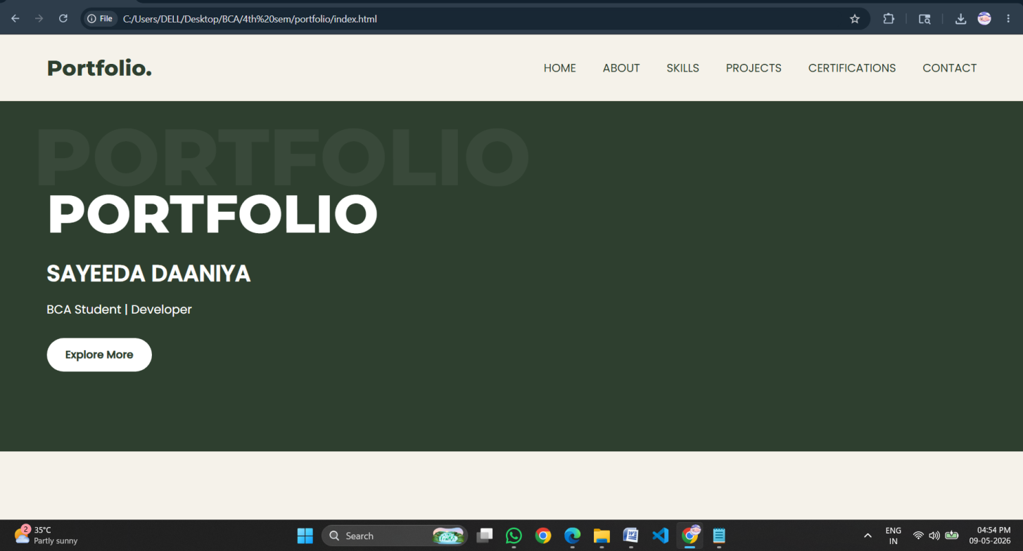

About.html:

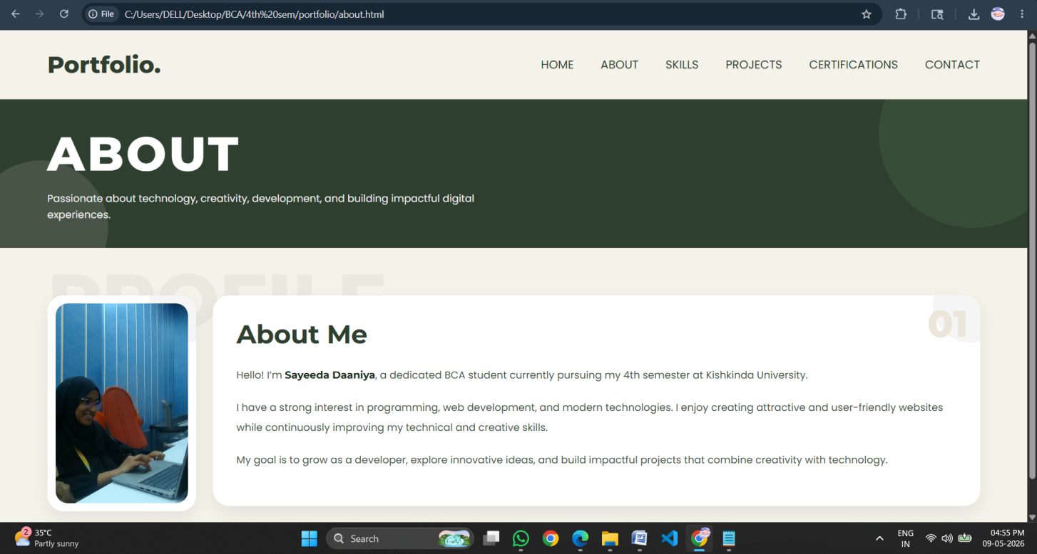

Skills.html:

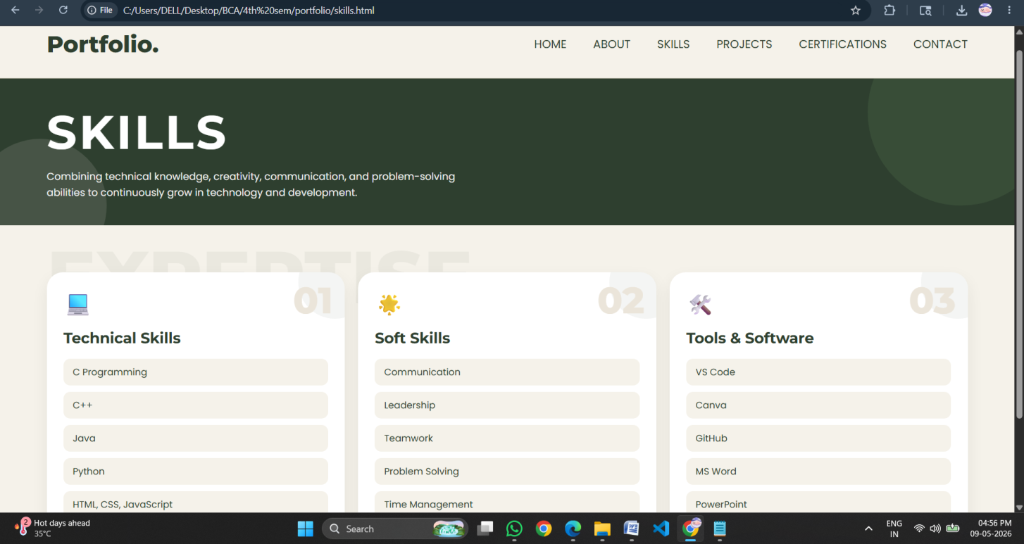

Project.html:

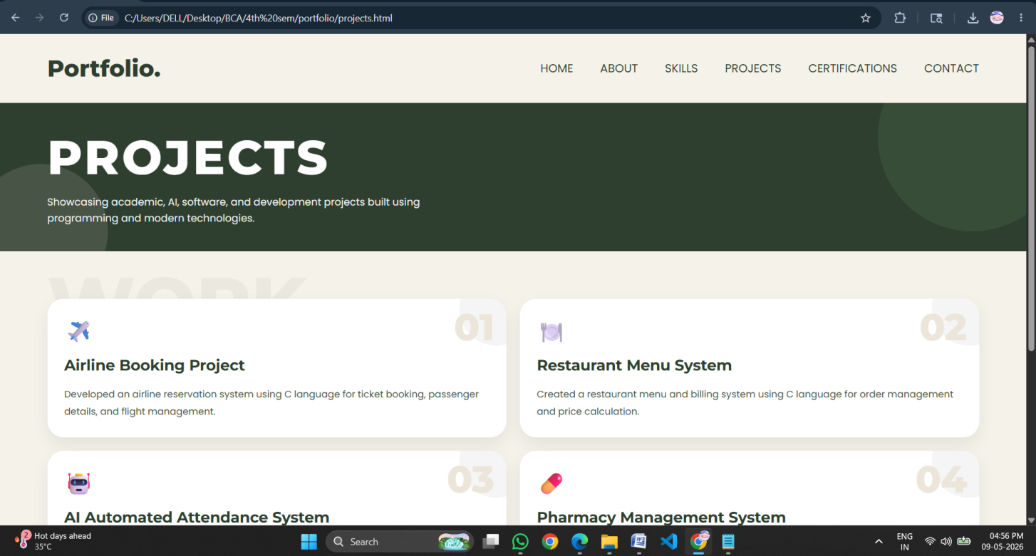

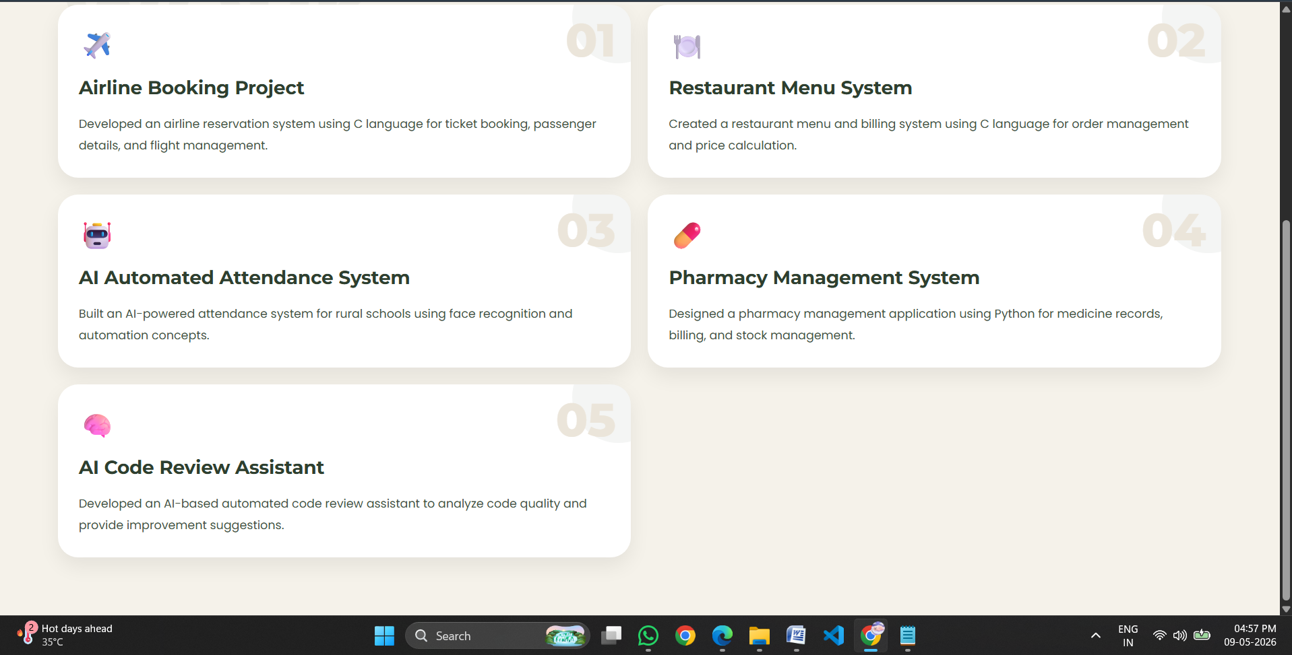

Certification.html:

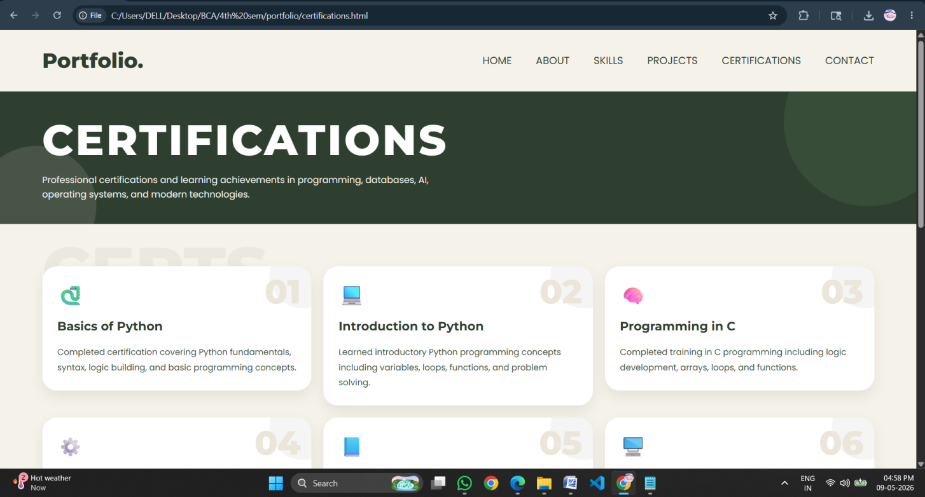

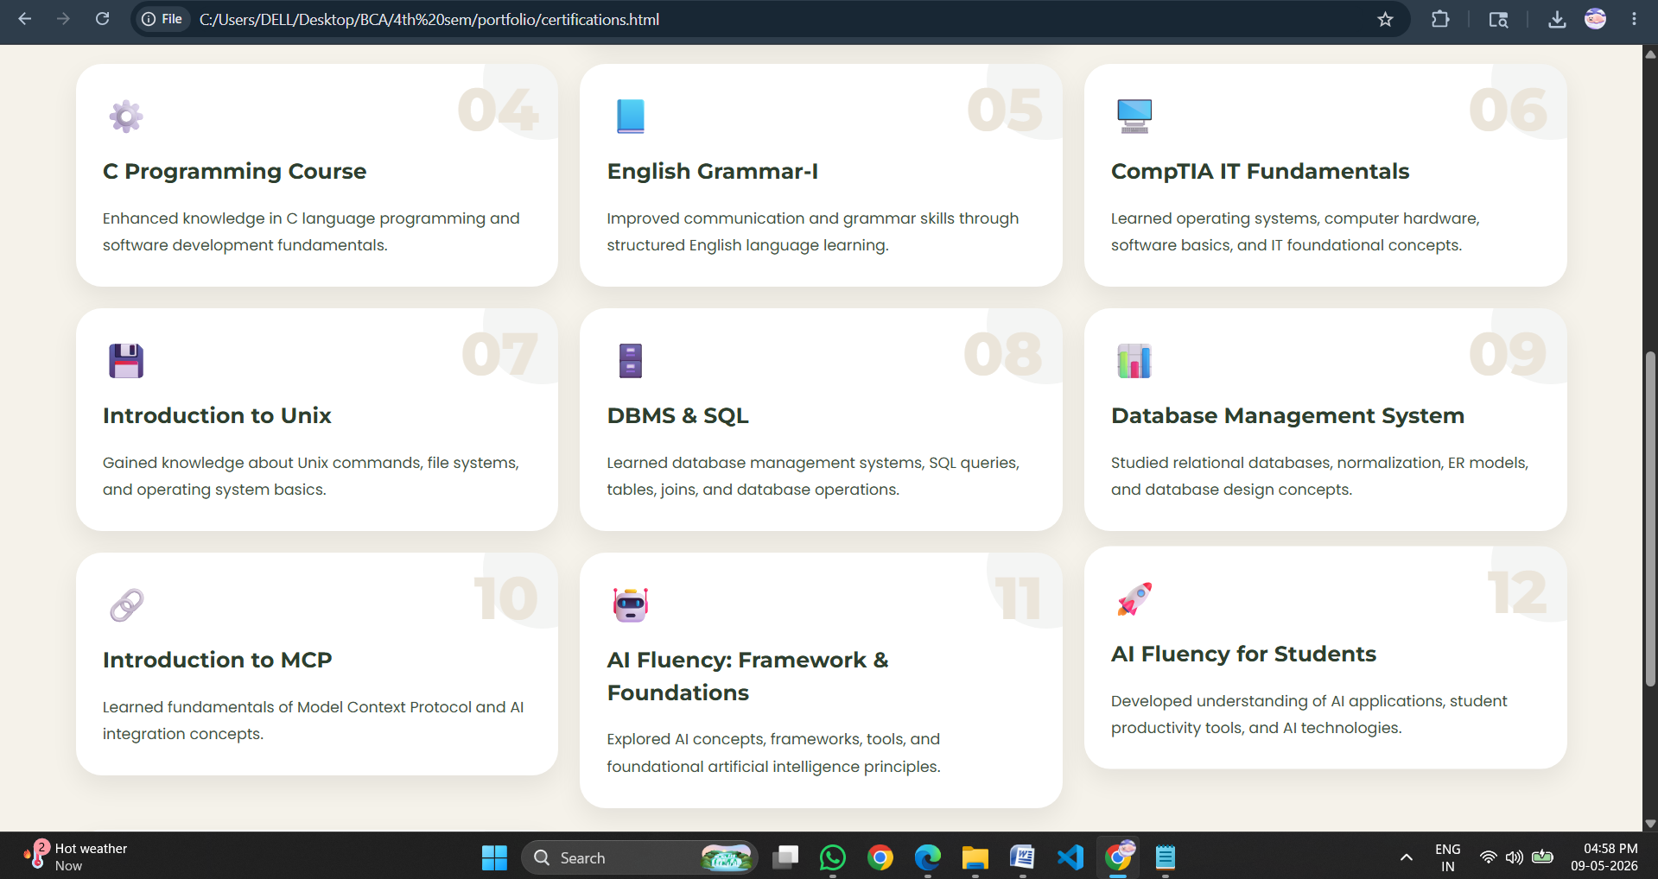

Contact.html:

